Chapter 10
Managing Software Projects
10.1. Need for the Proper Management of Software Projects
- Concerned with activities involved in ensuring that software is delivered on time and on schedule and in accordance with the requirements of the organizations developing and procuring the software.
- Project management is needed because software development is always subject to budget and schedule constraints that are set by the organization developing the software.
Software Project Management
• The product is intangible.
• The product is uniquely flexible.
• Software engineering is not recognized as an engineering discipline
• The software development process is not standardized.
• Many software projects are 'on-off' projects.
Software Management Distinctions

10.2. Management Activities
• Proposal writing.
• Project planning and scheduling.
• Project costing.
• Project monitoring and reviews.
• Personnel selection and evaluation.
• Report writing and presentations.
Project Staffing
• May not be possible to appoint the ideal people to work on a project
– Project budget may not allow for the use of highly paid staff;
– Staff with the appropriate experience may not be available;
– An organization may wish to develop employee skills on a software project.
• Managers have to work within these constraints especially when there are shortages of trained staff.
Project Planning
• Probably the most time-consuming project management activity.
• Continuous activity from initial concept through to system delivery.
• Plans must be regularly revised as new information becomes available.
• Various different types of plan may be developed to support the main software project plan that is concerned with schedule
and budget.
Types of Project Plan
• Other than the project plan managers have to draw up other plans as well
– Quality plan : Describes the quality procedures and standards that will be used in a project
– Validation plan : Describes the approach, resources and schedule used for system validation
– Configuration management plan : Describes the configuration management procedures and structures to be used
– Maintenance plan : predicts the maintenance requirements of the system, maintenance cost and effort required.
– Staff development plan : describes how the skill and experience of the project team members will be developed.

Project Planning Process

Establish the project constraints
Make initial assessments of the project parameters
Define project milestones and deliverables
while project has not been completed or cancelled loop
Draw up project schedule
Initiate activities according to schedule
Wait ( for a while )
Review project progress
Revise estimates of project parameters
Update the project schedule
Re-negotiate project constraints and deliverables
if ( problems arise ) then
Initiate technical review and possible revision
end if
end loop

The Project Plan
• The project plan sets out:
– The resources available to the project;
– The work breakdown;
– A schedule for the work.
Project Plan Structure
• Introduction.
• Project organisation.
• Risk analysis.
• Hardware and software resource requirements.
• Work breakdown.
• Project schedule.
• Monitoring and reporting mechanisms.
Activity Organization
• Activities in a project should be organised to produce tangible outputs for management to judge progress.
• Milestones are the end-point of a process activity.
• Deliverables are project results delivered to customers.
• Deliverable are usually milestones but milestones need not to be deliverables.
Milestones in the RE Process
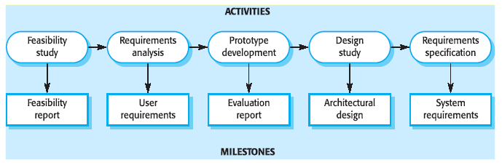

Fundamental Estimation Questions
• How much effort is required to complete an activity?
• How much calendar time is needed to complete an activity?
• What is the total cost of an activity?

Project estimation and scheduling are interleaved management activities.
Software Cost Components
• Hardware and software costs.
• Travel and training costs.
• Effort costs (the dominant factor in most projects)
– E.g. The salaries of engineers involved in the project, Social and insurance costs.
– Effort costs must take overheads into account
• Costs of building, heating, and lighting.
• Costs of networking and communications.
• Costs of shared facilities (e.g library, staff restaurant, etc.).
Costing and Pricing
• Estimates are made to discover the cost, to the developer, of producing a software system.
• There is not a simple relationship between the development cost and the price charged to the customer.
• Broader organisational, economic, political and business considerations influence the price charged.
Project Scheduling
• Split project into tasks and estimate time and resources required to complete each task.
• Organize tasks concurrently to make optimal use of workforce.
• Minimize task dependencies to avoid delays caused by one task waiting for another to complete.
• Dependent on project managers intuition and experience.
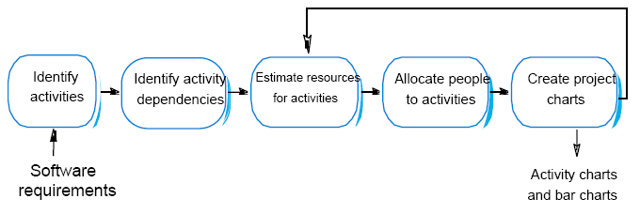
The Project Scheduling Process

Scheduling Problems
• Estimating the difficulty of problems and hence the cost of developing a solution is hard.
• Productivity is not proportional to the number of people working on a task.
• Adding people to a late project makes it later because of communication overheads.
• The unexpected always happens. Always allow contingency in planning.
Risk Management
• Risk management is concerned with identifying risks and drawing up plans to minimize their effect on a project.
• A risk is a probability that some adverse circumstance will occur
– Project risks affect schedule or resources;
– Product risks affect the quality or performance of the software being developed;
– Business risks affect the organization developing or procuring the software.
Software Risks
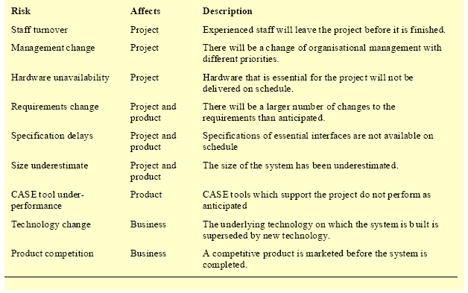

The Risk Management Process
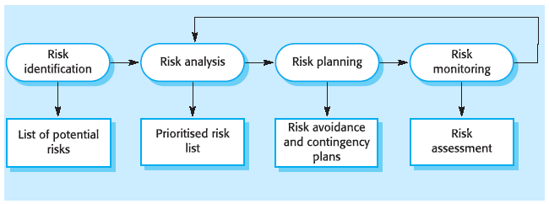

The Risk Management Process
• Risk identification
– Identify project, product and business risks;
• Risk analysis
– Assess the likelihood and consequences of these risks;
• Risk planning
– Draw up plans to avoid or minimise the effects of the risk;
• Risk monitoring
– Monitor the risks throughout the project;
Risk Identification
• Technology risks.
• People risks.
• Organisational risks.
• Requirements risks.
• Estimation risks.
Risks and Risk Types
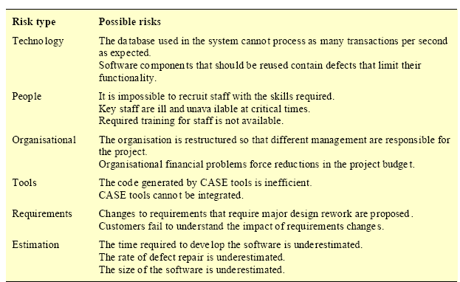

Risk Analysis
• Assess probability and seriousness of each risk.
• Probability may be
– Very low (<10%),
– Low (10-25%),
– moderate (25-50%),
– high (50-75%), or
– very high (>75%) .
• Risk effects might be
– catastrophic,
– serious,
– tolerable or
– insignificant.

Risk Probability Effects

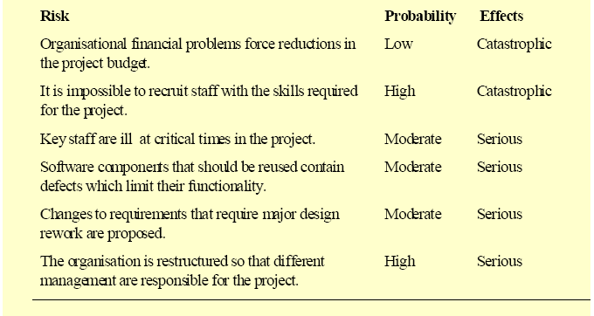

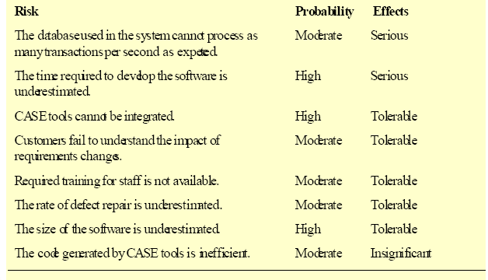

Risk Planning
• Consider each risk and develop a strategy to manage that risk.
• Avoidance strategies
– The probability that the risk will arise is reduced;
• Minimization strategies
– The impact of the risk on the project or product will be reduced;
• Contingency plans
– If the risk arises, contingency plans are plans to deal with that risk;
Risk Management Strategies
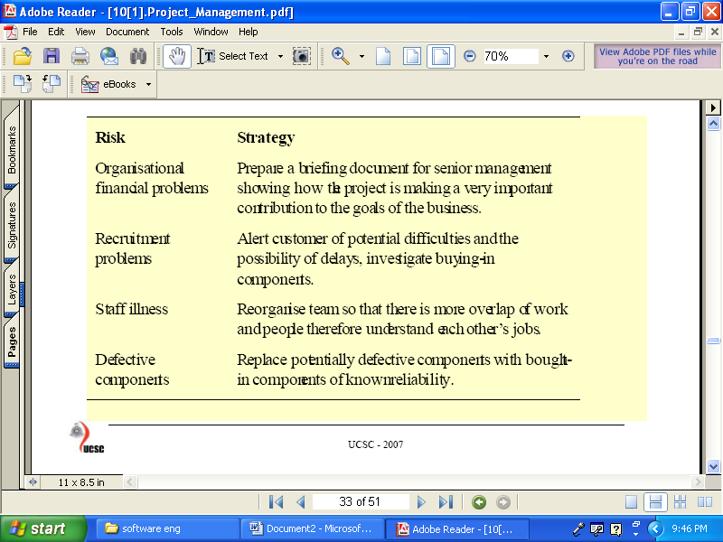
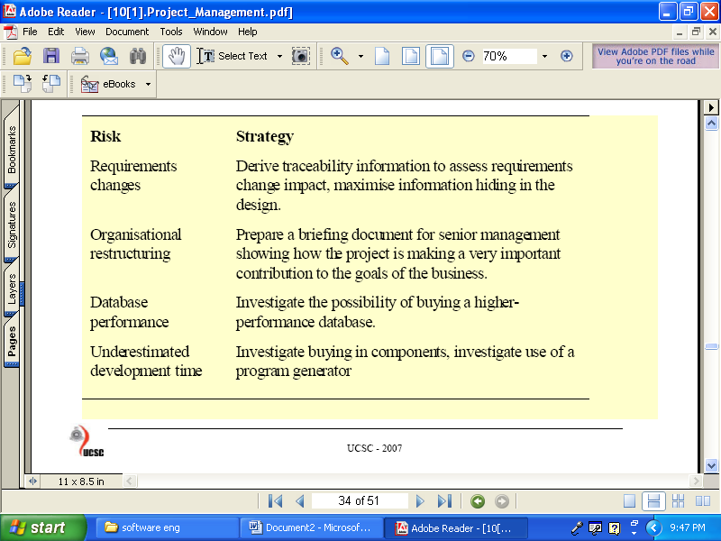

Risk Monitoring
• Assess each identified risks regularly to decide whether or not it is becoming less or more probable.
• Also assess whether the effects of the risk have changed.
• Each key risk should be discussed at management progress meetings.
Risk Indicators
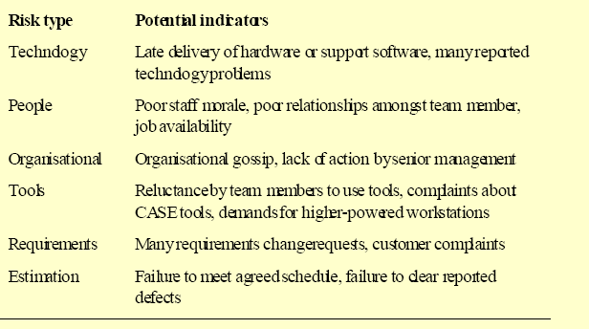

Managing People
People in the Process
• People are an organisation’s most important assets.
• The tasks of a manager are essentially people oriented. Unless there is some understanding of people, management will be
unsuccessful.
• Poor people management is an important contributor to project failure.
People Management Factors
• Consistency
– Team members should all be treated in a comparable way without favourites or discrimination.
• Respect
– Different team members have different skills and these differences should be respected.
• Inclusion
– Involve all team members and make sure that people’s views are considered.
• Honesty
– You should always be honest about what is going well and what is going badly in a project.
Selecting Staff
• An important project management task is team selection.
• Information on selection comes from:
– Information provided by the candidates.
– Information gained by interviewing and talking with candidates.
– Recommendations and comments from other people who know or who have worked with the candidates.
– Competitive Exam
Motivating People
• An important role of a manager is to motivate the people working on a project.
• Motivation is a complex issue but it appears that their are different types of motivation based on:
– Basic needs (e.g. food, sleep, etc.);
– Personal needs (e.g. respect, self-esteem);
– Social needs (e.g. to be accepted as part of a group).
Personality Types
• The needs hierarchy is almost certainly an over simplification of motivation in practice.
• Motivation should also take into account different personality types:
– Task-oriented;
– Self-oriented;
– Interaction-oriented.
• Task-oriented.
– The motivation for doing the work is the work itself;
• Self-oriented.
- The work is a means to an end which is the achievement of individual goals - e.g. to get rich, to play tennis, to
travel etc.;
• Interaction-oriented
- The principal motivation is the presence and actions of co-workers. People go to work because they like to go to
work.
Managing Groups
• Most software engineering is a group activity
- The development schedule for most non-trivial software projects is such that they cannot be completed by one
person working alone.
• Group interaction is a key determinant of group performance.
• Flexibility in group composition is limited
– Managers must do the best they can with available people.
Factors Influencing Group Working
• Group composition.
• Group cohesiveness.
• Group communications.
• Group organization.
Group Composition
• Group composed of members who share the same motivation can be problematic
– Task-oriented - everyone wants to do their own thing;
– Self-oriented - everyone wants to be the boss;
– Interaction-oriented - too much chatting, not enough work.
• An effective group has a balance of all types.
• This can be difficult to achieve software engineers are often task-oriented.
• Interaction-oriented people are very important as they can detect and defuse tensions that arise.
Group Cohesiveness
• In a cohesive group, members consider the group to be more important than any individual in it.
• The advantages of a cohesive group are:
– Group quality standards can be developed;
– Group members work closely together so inhibitions caused by ignorance are reduced;
– Team members learn from each other and get to know each other’s work;
– Egoless programming where members strive to improve each other’s programs can be practiced.
Group Communications
• Good communications are essential for effective group working.
• Information must be exchanged on the status of work, design decisions and changes to previous decisions.
• Good communications also strengthens group cohesion as it promotes understanding.
Group Organisation
• Small software engineering groups are usually organised informally without a rigid structure.
• For large projects, there may be a hierarchical structure where different groups are responsible for different sub-projects.
Working Environments
• Work place makes an important effect on worker’s performance and their job satisfaction.
• The most important environmental factors identified:
– Privacy: Programmers require an area where they can concentrate and work without interruption.
– Outside awareness: People prefer to work in natural light and with a review of the outside environment.
– Personalisation: Individuals adopt different working practices and have different opinions on décor. The ability to
rearrange the workplace to suit working practices and to personalise that environment is important.
People Capability Maturity Model
• P-CMM which is comprised of 5 levels, can be used as a framework for improving the way in which an organization
manages its human assets.
– Initial : Ad hoc, informal people management practices.
– Repeatable: Establishment of policies for developing the capability of the staff.
– Defined: Standardisation of best people management practice across the organisation.
– Managed: Quantitative goals for people management.
– Optimizing: Continuous focus on improving individual competence and work-force motivation.

